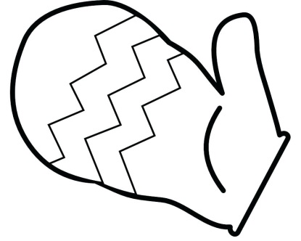
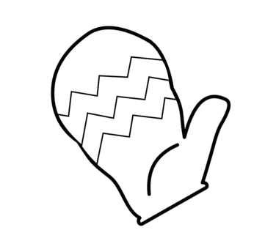
Warm Mittens
I wiggle my left hand,
I wiggle my right,
inside of my mittens,
so warm and so tight.

I wiggle my pinkie,
I wiggle my thumb,
so when I make snowballs,
my hands don't get numb.
