Tall and Short
First I bend my knees,
Then I stand up tall.
Down, up, down, up
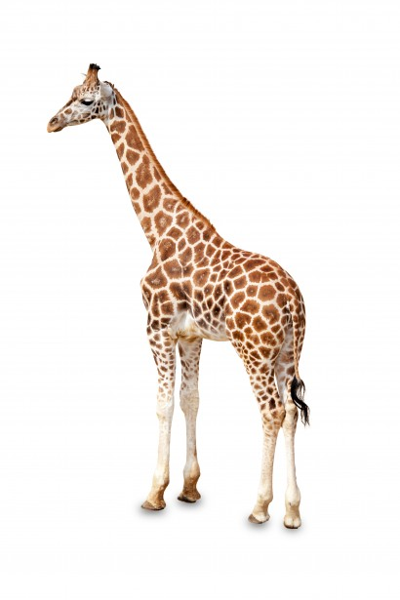
Like a bouncy ball.
First I’m short
Then I’m tall.

