I have a little spider,
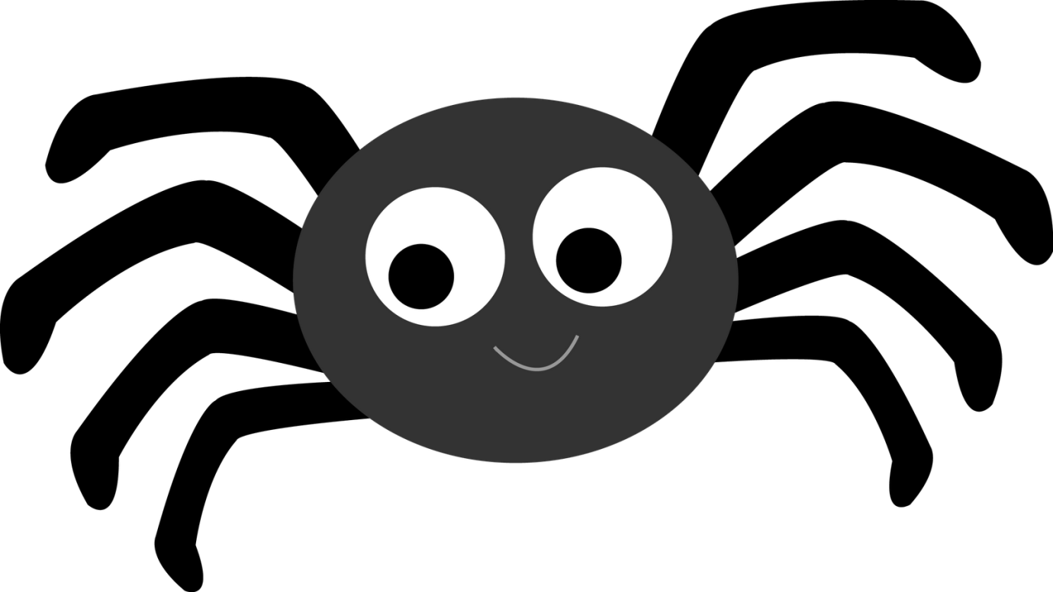
I have a little spider,
And I'm very fond of him;
He climbs on to my shoulder,
And then up to my chin;
He crawls down my arm,
And then down my leg;
Now he's a tired little spider
So I put him into bed.

