Five little Pumpkins
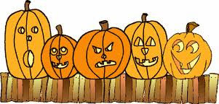
Five little pumpkins sitting on a gate.
The first one said, "Oh my it's getting late."
The second one said, "There are witches in the air."
The third one said, "But we don't care!"
The fourth one said, "Let's run and run and run."
The fifth one said, "Isn’t Halloween fun?"
So “OOOhh OOOhh” went the wind
And out went the lights
Then the five little pumpkins rolled out of sight.

1 2 3 4 5

