Five Little Firemen
Five little firemen standing in a row,
1 2 3 4 5 let’s go.
Jump on the engine with a SHOUT,
As quick as a wink the fire is out.

Four little firemen standing in a row,
1 2 3 4 woosh let’s go.
Jump on the engine with a SHOUT,
As quick as a wink the fire is out.

Three little firemen standing in a row,
1 2 3 woosh woosh let’s go.
Jump on the engine with a SHOUT,
As quick as a wink the fire is out.

Two little firemen standing in a row,
1 2 woosh woosh woosh let’s go.
Jump on the engine with a SHOUT,
As quick as a wink the fire is out.

One little fireman standing in a row,
1 woosh woosh woosh woosh let’s go.
Jump on the engine with a SHOUT,
As quick as a wink the fire is out.

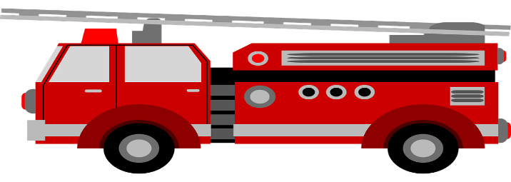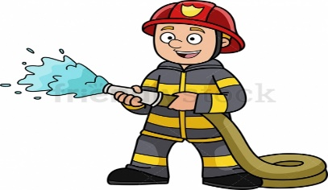
This Photo by Unknown Author is licensed under CC BY-SA-NC

