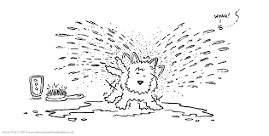
After A Bath
by Aileen Fisher
After my bath
I try, try, try
to wipe myself
till I’m dry, dry, dry.
Hands to wipe
and fingers and toes
and two wet legs
and a shiny nose.
Just think how much
less time I’d take
if I were a dog
and could shake, shake, shake.

